**COMIC TRANSLATOR (Ongoing)**

K S ASWATH RAMANA

**Project Overview**

In an increasingly globalized world, manga and comics from various cultures have gained immense popularity. However, language barriers often prevent readers from fully enjoying these works. The aim of this project is to develop a sophisticated manga translator that seamlessly translates text from the original language into the reader's desired language. This tool empowers fans worldwide to access and appreciate manga and comics, regardless of the language in which they were originally published.

**Purpose**

The manga translator is designed to bridge the linguistic divide between creators and global audiences. By automating the process of text extraction, translation, and re-integration into the manga pages, this tool offers a streamlined and user-friendly solution for fans who wish to read manga in their preferred language. Whether you're an avid manga enthusiast or a casual reader, this project ensures that language is no longer a barrier to enjoying the rich storytelling and artistry of manga from around the world.

**Workflow Overview**

The manga translator operates through a series of sophisticated steps designed to ensure accurate text translation and seamless integration back into the original manga panels. The workflow is as follows:

1. Optical Character Recognition (OCR): The first step involves applying OCR techniques to detect and extract all the textual content present within the manga panels. This process identifies the location and content of the text, converting it from image data to machine-readable text.
2. Bounding Box Detection and Density Clustering: After the text is recognized, the system identifies the precise location of each text instance by drawing bounding boxes around them. To manage areas with high concentrations of text, density-based clustering algorithms are applied. This ensures that overlapping or closely situated text is accurately grouped and processed.
3. Text Removal via Inpainting: Once the text regions are identified, the original text within each bounding box is removed using advanced image inpainting techniques. This step restores the background artwork in a way that maintains the visual integrity of the manga panel.
4. Text Translation: The extracted text is then translated from the original language to the target language specified by the user. This translation step leverages machine translation models or APIs to ensure that the meaning and context of the text are preserved. Currently Marian Model is used.
5. Text Embedding: The final step involves embedding the translated text back into the original manga panel. The translated text is carefully placed within the same bounding boxes where the original text was located, ensuring that the visual flow and readability of the manga are maintained.

**Challenges Encountered**

1. Optical Character Recognition (OCR) Selection

Choosing an appropriate OCR library was a significant challenge. While widely used libraries like Tesseract are popular, they often struggle with sparse text or text over varying backgrounds, common in manga. After extensive testing, Doctr OCR was selected for its superior performance in detecting sparse text. However, even Doctr OCR is not without its limitations; it occasionally mis detect text or fails to identify text altogether, sometimes even detecting non-text elements as text.

1. Inpainting Issues

The removal of original text is achieved through inpainting techniques, with OpenCV’s inpainting tool currently in use. However, this approach presents visible challenges. The inpainting process can leave noticeable smudges or artifacts where the text was removed, compromising the visual quality of the manga panel. Achieving a seamless restoration of the artwork remains a significant area for improvement.

1. Translation Accuracy

Translating text accurately without the surrounding context is another hurdle. Machine translation models typically process isolated text strings, which can result in translations that lack the correct nuance or context. This limitation often leads to translations that are technically correct but fail to convey the intended meaning or emotion as effectively as the original language.

**Approaches to Overcoming Challenges**

As the project progresses, several strategies are being explored to address the challenges encountered:

1. **Enhancing OCR Accuracy**

To improve the accuracy of OCR, various preprocessing techniques are being trialed. These include upscaling and denoising the images to enhance text clarity, followed by edge detection and Otsu’s thresholding to better distinguish between the text (foreground) and the background. By experimenting with different combinations of these techniques, the goal is to identify the most effective approach for improving text detection accuracy in manga panels.

1. **Improving Inpainting Quality**

To address the issue of visible smudges left by OpenCV’s inpainting tool, an alternative approach using **LaMa Cleaner** is being explored. LaMa Cleaner is an advanced AI-based tool designed for seamless object removal and background filling. By integrating LaMa Cleaner, the aim is to achieve a more refined and seamless inpainting process that effectively removes text while preserving the visual integrity of the manga artwork.

1. **Contextual Translation Enhancement**

Given the challenges of translating text without context, efforts are being made to explore context-aware translation models or additional preprocessing steps that can group related text strings for translation. This approach could improve the coherence and accuracy of the translated text, ensuring that the final output retains the intended meaning and nuance of the original language.

**Images**

Text Detection and Clustering of those text.

Removal of Text after Detection using CV2’s inpainting tool

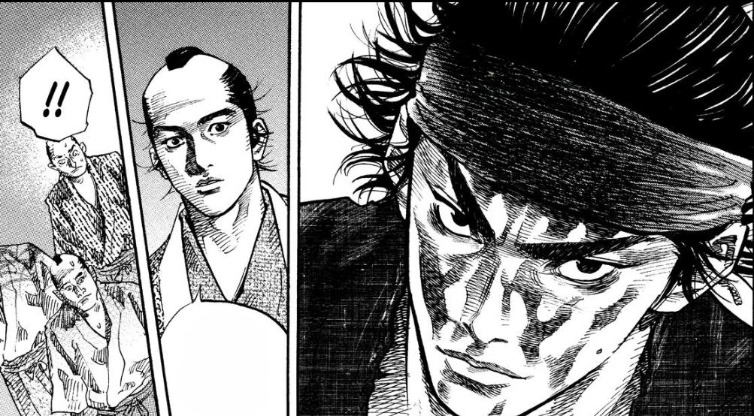

Removal of Text using LaMa Cleaner